At 97, Fair Lawn woman still loves to learn
Sunday, July 25, 2010
The Record
SPECIAL TO THE RECORD
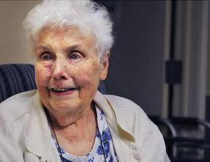

DAVID BERGELAND/STAFF PHOTOGRAPHER

